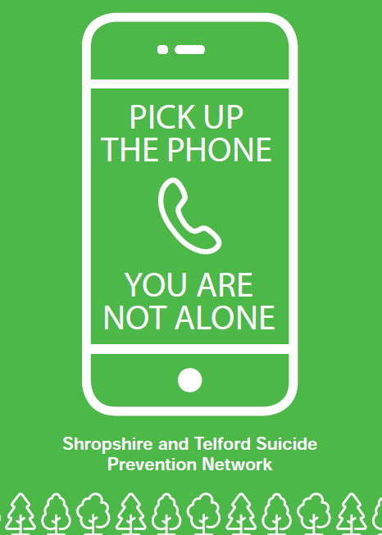

Preventing Suicide

in Primary Care

Suicide prevention, self-harm and suicide bereavement

**Resource Pack**

**Suicide is not inevitable and can be preventable**

**It is also complex and rarely due to one cause**

**Introduction**

This resource pack has been adapted by the Shropshire and Telford & Wrekin Suicide Prevention Network to help support Primary Care including General Practice colleagues with suicide prevention.

|  |  |
| --- | --- |
| **Suicide has a significant, lasting and often devastating impact** | Economically, psychologically and spiritually - on individuals, families, communities, and the wider society |
| **Suicide prevention is everybody’s business** | 1 in 5 people have had suicidal thoughts at some point in their lives. Most of us may have been affected by suicide in some way either directly or indirectly |
| **Suicide is not inevitable and can be preventable** | It is also complex and rarely due to one cause.  Suicides are preventable with timely, evidence based interventions. Everyone has a role in suicide prevention. Many people who die by suicide have been in contact with Primary Care during their final year and commonly in the final month of their life which is why this pack has been produced |
| **Everyone working in Primary Care and Pharmacy has a role in preventing suicide** | Regardless of role, grade or experience.  Knowing more about the risk factors involved in suicide, recognising the signs and most importantly asking as well as knowing where to signpost people who may be at risk is something we can all do. There are a number of opportunities during patient contacts for Primary and Pharmacy staff to intervene and helped reduce the risk of suicide. |

Whilst this resource pack is primarily aimed at how we work with patients and service users in primary care, we also acknowledge that suicide may impact on us personally including our colleagues, our families and our friends. The information contained here is relevant for any professional and personal role in life.

This pack is divided into sections with helpful resources contained within each section as well as additional resources at the end of the pack.

Thanks is given to the Nottingham and Nottinghamshire Suicide Prevention Strategic Steering Group for agreeing for their original resource to be localized.

Contents

Primary Care Suicide Prevention Poster 4

Why Suicide is a Concern 5

Definitions and language around suicide and self-harm 6

What we know about suicide and self-harm in Shropshire, Telford & Wrekin 11

Risk Factors 12

Risk assessment is not Suicide prediction 13

Recognising the signs 13

Responding to thoughts of suicide and self-harm 14

Exploring causes and things that could help 14

Safety Planning 15

Family involvement 16

Getting people to the right help 17

Primary Care specific suicide prevention actions 18

Risk of overdose from medication 20

Resources for clinical practice 21

Bereavement by suicide 22

Suicide prevention and self-harm awareness training 23

Looking after yourself as a primary care practitioner 24

Resources for primary care practitioners 24

Signposting and Resources List 26

Crisis Services 26

First Point of Contact Resources and Tools to help keep people safe 26

Support for Children and Young People 26

Online safety 27

Community Support and Listening Ear 27

Self-Harm 28

Safety planning 28

Local Information and Resources 29

Bereavement support 29

Local Support 29

Information 29

National Resources 29

Practical Support and Advice 30

Appendix 1: Medicines and suicide professional aide memoire 31

Appendix 2: Shropshire and Telford & Wrekin Bereavement Service Flyer 33

# Primary Care Suicide Prevention Poster

**Suicide prevention: are you concerned about someone?**



**Recognise the signs:** loss of job or relationship, sense of withdrawing, self-harm or talking about suicide. There may be suicidal thoughts. There may be no signs at all. It’s always safest to ask.

**What to say:** it’s normal to feel anxious but it’s safer to say something rather than nothing. Ask open questions and if in doubt, ask directly.

**Listen to the person.** It may take a lot of courage for them to talk to you about how they are feeling.

**Offer to support them in seeking help.** There are lots of places where they can get confidential advice and support NHS 111 online or call 111MPFT 24/7 Urgent Mental Health Helpline: 0808 196 4501, Shropshire MHS: 01743 368647, Telford Mind: 07434 869248 or the **Samaritans 116 123.**

**Get medical help:** If someone is at immediate risk (if they have made plans or harmed themselves), get immediate medical help or call 999.

**Share concerns with colleagues who may also be supporting that person.** Pass on information about any support you’ve given them. Talk to your manager and don’t take concerns home.

**Look after yourself:** be active & connect with others.

Get support if you need it from the STW Staff Psychological Wellbeing Hub: stwtraininghub.co.uk/staff-psychological-wellbeing-hub or call the NHS support line: 0800 0696222 **(open 7 days from 7am-11pm).**

**Learn more:** Free 20 minute suicide prevention online learning from the Zero Suicide Alliance [www.zerosuicidealliance.com/training](http://www.zerosuicidealliance.com/training)

1

2

3

4

5

6

7

8

**You won’t increase the risk by talking about it**

# Why Suicide is a Concern

**Suicide is the leading cause of death among young people aged 20 to 34 years in the UK (ONS, 2015)**

**Suicide is now the leading cause of premature mortality in men younger than 50, followed by heart disease**

**Those who are bereaved by suicide are at three times the risk of making a suicide attempt themselves**

**1 in 8 LGBTQ+ people aged 18 to 24 years have attempted to take their own life and almost half of all trans people have thought about taking their life**

**Autistic adults are nine times more likely to die by suicide than the general population and suicide is the second leading cause of death for autistic people**

**Suicide is preventable with timely, evidence-based interventions**

**Families, friends, colleagues and communities will be affected as a result of each suicide. It is estimated that for every person who dies because of suicide at least 115 people are affected**

**We must ensure that individuals who may be considering taking their own lives are supported so that all suicides that could be prevented are prevented**

# Definitions and language around suicide and self-harm

Suicide The act of taking one’s own life, with varying suicidal intent.

Suicidality The term suicidality embraces all aspects of suicidal processes including suicide, non-fatal suicidal behaviour and suicidal ideation.

Self-harm Self-harm is when somebody intentionally harms or injures their body. It is often a way of coping and/or expressing overwhelming emotional distress.

Language around suicide and self-harm is important to help reduce stigma and create a common understanding. Below are some more helpful terms we can use.

Suicide Prevention: Creating Hope Through Language

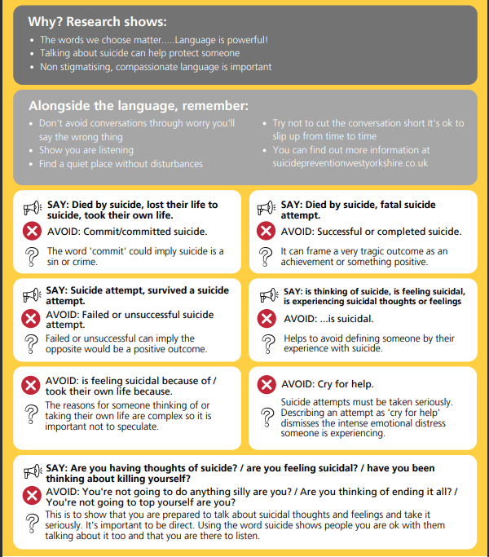



Myths about suicide

There are lots of myths around suicide – understanding the facts can help you to help someone struggling to cope. The following have been adapted from the Samaritans information available here Myths about suicide (samaritans.org)

**Myth: You can’t ask someone if they’re having thoughts of suicide**

**Fact:** Evidence shows asking someone if they’re suicidal could protect them. Asking someone if they’re having thoughts of suicide can give them permission to tell you how they feel and let them know they are not a burden.

**Myth: People who talk about suicide aren't serious and won't go through with it.**

**Fact:** People who die by suicide have often told someone that they do not feel life is worth living or that they have no future. Some may have said they want to die.

It's possible that someone might talk about suicide as a way of getting attention, in the sense of calling out for help.

It’s important to always take someone seriously if they talk about feeling suicidal. Helping them get the support they need could save their life.

**Most people who feel suicidal do not actually want to die - they just want the situation they’re in or the way they’re feeling to stop.**

**Myth: If a person is serious about killing themselves then there's nothing you can do.**

**Fact:** Often, feeling actively suicidal is temporary, even if someone has been feeling low, anxious or struggling to cope for a long period of time. Getting the right kind of support at the right time is so important.

In a situation where someone is having suicidal thoughts, be patient, stay with them and just let them know you're there. Remember, if you think it's an emergency or someone had tried to harm themselves- call 999

**Myth: You have to be mentally ill to think about suicide.**

**Fact:** 1 in 5 people have thought about suicide at some time in their life. And not all people who die by suicide have a diagnosed mental health condition at the time they die.

However, many people who die by suicide have struggled with their mental health, typically to a serious degree. This may or may not be known before the person's death.

**Myth: People who are have thoughts of suicide want to die.**

**Fact:** Most people who feel suicidal do not actually want to die; they just want the situation they’re in or the way they’re feeling to stop. The distinction may seem small, but it is very important. It's why talking through other options at the right time is so vital.

**Myth: Talking about suicide is a bad idea as it may give someone the idea to try it.**

**Fact:** Suicide can be a taboo topic. Often, people who have thoughts of suicide don’t want to worry or burden anyone with how they feel and so they don’t discuss it.

But, by asking someone directly about suicide, you give them permission to tell you how they feel. People who are struggling or have thoughts of suicide will often say what a huge relief it was to be able to talk about what they were experiencing.

Once someone starts talking, they’ve got a better chance of discovering options that aren't suicide.

**Myth: Most suicides happen in the winter months.**

**Fact:** Suicide is complex, and it's not just related to the seasons and the climate being hotter or colder and having more or less light. In general, suicide is more common in the spring, and there's a noticeable peak in risk through the New Year period.

**Myth: People who say they are going to take their own life are just attention seeking and shouldn’t be taken seriously.**

**Fact:** Talking openly about suicide to a loved one, colleague, professional or a Samaritan can help someone work through their thoughts and help them find a way to cope. People who say they want to end their lives should always be taken seriously. It may well be that they want attention in the sense of calling out for help and helping them get support may save their life.

Being able to talk openly about suicide can help someone work through their thoughts.

**Myth: You can’t tell when someone is having thoughts of suicide**

**Fact:** Suicide is complex and how people act when they’re struggling to cope is different for everyone. Sometimes there are signs someone might be going through a difficult time or having difficult thoughts. For some people, several signs might apply - for others just one or two, or none.

[**Find out more on how to spot the signs that someone may not be OK.**](https://www.samaritans.org/how-we-can-help/if-youre-worried-about-someone-else/how-support-someone-youre-worried-about/)

# What we know about suicide and self-harm in Shropshire, Telford & Wrekin

Talking about suicide and self-harm doesn’t increase the risk of someone making a suicide attempt or harming themselves.

Thinking about suicide is more common than we think and is potentially preventable.

**When we consider suicide statistics it is important that we remember each is an individual that has lost their life to suicide.**

The causes of suicide are complex and the number of deaths by suicide fluctuate over time.

* 1 in 5 people will have thoughts of suicide in their lifetime.
* In England, approximately one person dies every two hours because of suicide. In 2020-2022 rates of suicide in Shropshire were 12.9 per 100,000 population and 11.1 per 100,000 for Telford & Wrekin (England & Wales rates = 10.3 per 100,000 population).
* Bereavement from suicide can affect approximately 135 people who knew the individual, including professionals. Bereavement by suicide is a risk factor particularly for close family members, around 3-4 times that of the general population.

Self-harm is the act of deliberately hurting self as a way of dealing with emotional distress.

* The severity of self-harm is not linked to level of distress.
* People who self-harm are 20 times more likely to die from suicide.
* 50% of people who die by suicide have a history of self-harm.
* In 2014, rates of self-harm were 408 per 100,000 population.
* Self-harm rates in middle aged men and younger women have been increasing since 2008.

Latest data and information on UK suicide can be accessed in the NCISH Annual Report: [NCISH | Annual report 2024: UK patient and general population data 2011-2021 (manchester.ac.uk)](https://sites.manchester.ac.uk/ncish/reports/annual-report-2024/) - relating to people aged ten and above who died by suicide between 2011 and 2021 across all of the UK.

# Risk Factors

Whilst suicide can affect anyone, some groups are at higher risk of suicide. Some of the

groups who may be at higher risk of suicide include

* **Men**: More men than women die by suicide – nationally the ratio of male to female
* deaths is 3:1
* **Middle Ages**: For the period 2012-2014 the highest rate of suicide occurred in the 35-64 age group for both males and females
* **Older people** may also be at risk, particularly those experiencing loneliness and isolation
* **Deprived communities**: Those in the poorest socio-economic group are 10 times more at risk of suicide than those in the most affluent group.
* **People who self-harm** are at increased risk of suicide. UK studies have estimated that in the year after an act of deliberate self-harm the risk of suicide is 30–50 times higher than in the general population.
* **People in other groups** such as **lesbian, gay, bisexual or transgender people** and **people with autism** and others who are neurodivergent

**There are a wide range of other factors that can contribute to suicide. Be aware of common risk factors and if in doubt ask about suicide.** The list of risk factors is not exhaustive but includes:

* **family history and early trauma**
* **poor mental health**, including people with a history of untreated depression and people in the care of mental health services. The highest risk of suicide group are patients up to 4 weeks following discharge from a psychiatric hospital, with an estimated increased risk of 100-200 times
* **physical illness**, long term pain and chronic conditions
* **relationship breakdown**, domestic abuse and other life event such as a bereavement – particularly those bereaved by suicide
* **debt and unemployment**
* **working in certain occupational groups** such as such as doctors, nurses, dentists, veterinary workers, farmers and agricultural workers, veterans

Domestic abuse can increase the risk of suicide. In women who experience domestic

abuse this can be three times the risk. Victims of domestic abuse are also more likely to

experience self-harm and increased thoughts about suicide.

**Be aware of risk factors such as loss of/changes in employment which may cause**

**financial vulnerability, relationship breakdown where there may be housing issues or**

**increased loneliness or where domestic abuse has played a part (victims/perpetrators),**

**changes in physical health which may cause people to feel hopeless, people using**

**inappropriate coping mechanisms such as overuse of alcohol, substances or gambling.**

# Risk assessment is not Suicide prediction

**Risk assessments should not be used to predict suicide risk**. There is no evidence that

suicide can be predicted using any algorithm, tool or checklist.

Because suicide is a relatively rare event, and suicidal intent can change rapidly, it is not possible to predict which patient will or will not attempt or die by suicide at any given point in time. The clinician’s role is to identify patients at higher risk of suicide and take steps to lower that risk.

However, such tools can be used as part of the process of information collection and are more helpful for identifying pertinent and modifiable factors which can be addressed and tailored to the individual. This can be used along with a co-produced Safety Plan to provide an agreed set of activities, strategies, people and organizations that a patient can rely on if they become suicidal or if their suicidal feelings increase.

Loss of contact with services might be an indicator of a risk particularly if this is a change

in usual behaviour. Attempting to re-establish contact can be considered a prevention

measure.

Clinicians should be aware of the features of those at suicide risk in the context of

economic adversity: most often middle-aged men, unemployed, divorced or separated, with

higher rates of alcohol or drug misuse. Onset of mental disorder, especially depression, may

have been recent; some lose contact with services. Working with organisations that support

people facing debt or other financial problems is important to prevention.

Clinicians should be aware of the risk from opioids prescribed for pain. Safer prescribing in

primary and secondary care is important to prevention. Assessment of risk should include

access to opioids available at home, particularly among older patients (see pages 16 and 17

on safer prescribing).

For young people, consider online use and how this might contribute to risk. Online use

can be positive or negative and can increase influences and exposure including forums and

access to means of suicide.

# Recognising the signs

It’s important we don’t make assumptions about someone we suspect may (or may not be)

having suicidal thoughts. Anyone can experience suicidal thoughts, but some things to be aware of when thinking about whether we should ask if someone is suicidal include:

* Recent “defeats” or loss of valued things in their life, for example the loss of a job or a relationship (defeat)
* The person is talking about feeling very hopeless, or that the future is bleak (hopelessness)
* They’ve spoken about how they can’t see a way that their situation will improve or
* change, or may feel like there’s no point in trying (feeling trapped/arrested flight)
* They’ve mentioned that they think people, society, or the world would be better off if they weren’t around (burdensomeness)
* They’ve said how they have nobody to turn to, how attempts to ask for help have gone badly, or there’s nowhere they belong anymore (lack of belonging)
* They appear to be withdrawing from daily life (e.g. school, work, or social life), or seem to have a “mask” that they wear to hide their feelings (isolation)
* They’ve spoken before about thinking/attempting suicide in the past under similar circumstances, or that they self-harm (history/risk factor)

Someone who is suicidal may show none of these things, and someone who is not suicidal

may show several. The best thing to do is ask. There is not always one pivotal moment in

someone’s life that suddenly causes suicidal thoughts (although there can be); sometimes a

build-up of months or even years of distress that can cause someone to go into crisis.

# Responding to thoughts of suicide and self-harm

Responding to suicide ideation

* Compassion makes a difference
* Take all suicidality and self-harm seriously
* Most people are making their best effort to cope
* Suicide is complex
* Suicide cannot be predicted by risk assessment tools

Suicide is complex and people may not show obvious signs. **IF IN DOUBT ASK.**

Self-harm and suicide are often not the same thing. If someone says they are not

having thoughts of suicide, this doesn’t mean they are not self-harming; ask these

questions separately and clearly.

# Exploring causes and things that could help

If someone is struggling to convey how they’re feeling, it can be helpful to explore how

they’re feeling by:

* Asking directly, “Are you self-harming/thinking of suicide?”. This can help the person
* by allowing them to simply say “Yes”, rather than having the pressure on them to say it themselves
* Having a conversation with the person rather than becoming very rigid and reading

from a list of questions. While there are some questions we need to ask to make sure the person is safe, the way we ask them is important.

* Consistent messages that they can get through this, with the right support. You may not be the person who will provide that ongoing support, but you may be the person who gets them on the right path.
* Not reinforcing or insisting on support strategies that the person knows by experience don’t work for them or would be risky. For example, never encourage the person to do something by themselves if they know being alone is risky for them; ask if they can include a friend, family member, or someone else.
* Having some knowledge and understanding of what other services exist, including non-mental health services which can help address a wide range of underlying circumstances. Suicidal thoughts aren’t always purely due to a mental health condition

sometimes, support to address mounting debt or impending homelessness is the key support needed, if the stress of this is the main part of someone’s suicide crisis.

# Safety Planning

Supporting a patient to put together a safety plan can be a helpful tool in enabling them to

navigate suicidal urges and feelings whilst also finding new ways in how to communicate

with the patient and identify any risks. A safety plan includes what the patient would do and who might support in a crisis. Evidence suggests they are effective at supporting people with suicidal thoughts when co-produced with the patient.

Safety plans can include:

* Signs of nearing crisis and what support can be sought out
* Internal coping strategies such as working with negative thoughts and checking out the facts
* Friends/family who can support/distract from thoughts and feelings
* Details/contact numbers of agencies and professionals that can help
* Ways in which to make it harder to harm themselves.

Safety plans should be completed at the point of any expression of thoughts of suicide, to be done collaboratively and individual to the person it’s for. It should also be kept simple with a few simple actions to avoid becoming overwhelming.

**Guidance on creating a Safety Plan**

Creating a ‘safety plan’ | Samaritans StayAlive - Essential suicide prevention for everyday life

StayingSafe.net – Safety plan template to complete electronically online or download. Also contains NHS England funded Staying Safe Training Materials | Staying Safe 40min training available for free

Safety Planning for Young People: [Suicide safety plan | Papyrus (papyrus-uk.org)](https://www.papyrus-uk.org/resource-suicide-safety-plan/)

MH Autism – safety plans for people with autism [http://mhautism.coventry.ac.uk/wp-content/uploads/2017/02/16557-17-Two-autism-booklet- GP-V4.1-FINAL.pdf](http://mhautism.coventry.ac.uk/wp-content/uploads/2017/02/16557-17-Two-autism-booklet-%20GP-V4.1-FINAL.pdf)

# Family involvement

Carers and families often have important information which will assist in diagnosis

and care.

There can be a tension between individual confidentiality and the sharing of

information which may protect life and prevent harm.

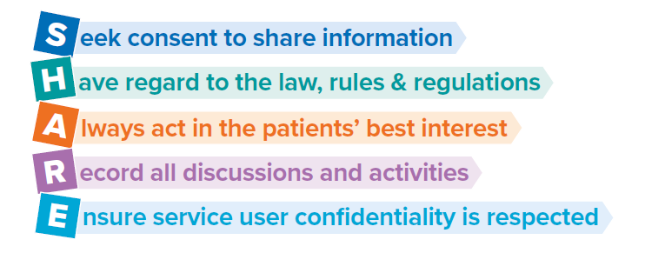

Primary Care should consider how they will respond to family members who raise

serious concerns regarding their loved ones. They are likely to have additional information

and be aware of risk that healthcare practitioners are not aware of and may be helpful in

providing appropriate care.

Particular groups, for example young adults (18–25-year-olds) may need extra monitoring

and support/involvement from their families. Families can be a useful source of support and

care for patients of any age.

Healthcare practitioners should seek advice from their Information Governance leads to

ensure there is no breach to GDPR legislation whilst balancing the needs and potential risks

to patients.

**Guidance for practitioners:**

* Consider the wellbeing of families, friends and carers and their potential to contribute to positive service user outcomes. Provision of general information about mental health difficulties, emotional and practical support does not breach confidentially.
* Routinely and frequently confirm with service users whether and how they wish their family, friends, or carers to be involved in their care.
* Routinely seek consent to involve nominated person in all clinical interactions and
* the service user should be encouraged to identify someone they trust with whom this information can be shared to optimise the support available to them,
* Record and act upon consent where this is given unless there is a demonstrable and

record reason why this is not appropriate

* Consider whether information disclosure may be in the public interest.

It is also important to consider information and support for carers and families both in terms of supporting someone else and their own needs.

**Resources that can support carers and families**

* Samaritans: [How to start a difficult conversation](https://www.samaritans.org/difficultconversations)
* Rethink: Suicidal thoughts - How to support someone
* MIND: How to help someone with suicidal feelings
* Carers Trust: [Support for Carers - Feeling Suicidal](https://carers.org/caring-for-someone-with-a-mental-health-problem/caring-for-someone-with-suicidal-thoughts)
* CALM: [Guide to supporting a mate](https://www.thecalmzone.net/help/worried-about-someone/)
* Papyrus: [Supporting your child: A Parent’s guide](https://www.papyrus-uk.org/wp-content/uploads/2023/07/Supporting-Your-Child-A5-Booklet-English-2023.pdf)

# Getting people to the right help

**Examples of how to effectively support patients to access services include:**

**“If I provide a list of available support, shall we look at it together?”**

**“You can read it in your own time, and we can review in a couple of days”**

**“Shall we look through this website and see whether anything looks helpful for you at the moment?”**

**“Is there anything I can do to help you to make that phone call”**

Signposting people to support often translates as giving them a leaflet and leaving them to contact services themselves. This can often be really overwhelming; people don’t know who to contact, what the offer is or find it difficult to tell their story again. Thinking of it as facilitating access to services and taking an active role in that can be more helpful to both sides.

There are a wide range of services available locally and nationally. Please view the Signposting and Resources List within this toolkit for the recommended services, additional resources and training available.

# Primary Care specific suicide prevention actions

**People often contact Primary Care in the last 3 months of their life, particularly those not in contact with other services giving Primary Care an important role in suicide prevention. Being aware of risk factors, asking about suicide, safer prescribing and offering longer and follow up appointments can all help.**

Many people who die by suicide have been in contact with Primary Care during their final year and commonly in the final three months of their life. Individuals may not present in relation to feelings of suicidality or mental health, they may be presenting due to other aspects of their health. They are often not in contact with other services.

Giving people time to talk through their concerns through offering extended appointments, giving a range of options and helping people develop safety plans are all suicide prevention measures. Proactively offering follow up appointments would also be appropriate.

Primary Care may wish to consider ways in which patients are experiencing distress are able to ask for extended appointments or share concerns on initial contact for appointments; this might be training reception staff with additional skills.

Healthcare practitioners can discuss concerns about patients with their Primary Care safeguarding leads.

Certain drugs may include side effects that increase the risk of suicidality so ensuring patients are aware of this and what to do in those situations should be considered.

Common characteristics of people who have died by suicide and have been in contact with Primary Care but are not under specialist mental health care preceding their death include:

* Polypharmacy of psychotropic, hypnotic and analgesic medication
* Comorbidities, in particular chronic pain
* Substance misuse
* Increasing frequency of consultation
* Domestic abuse
* Self-harm
* Neurodiversity
* Military personnel and veterans
* People with protected characteristics (including LGBTQ+, different ethnic backgrounds and disability or learning disability)
* Financial insecurity
* Problem gambling
* Housing issues or homelessness
* Criminal justice contact
* People from farming and rural communities

**Specific actions which Primary Care can consider as suicide prevention measures include**:

Knowledge and skills

* All staff to have at least basic knowledge and understanding of suicide risk and how to signpost (for example completion of the free online Zero Suicide Alliance Training available at: <https://zerosuicidealliance.com/training> )
* For staff who will be working with higher risk individuals for suicide to have enhanced knowledge and skills around safety planning and appropriate intervention. See training section for further details.

Consultation Conversation

* Professional curiosity, ask the individual and use a combination of looking, listening, asking direct questions, checking out and reflecting on ALL the information you receive, rather than making assumptions or taking information at face value
* Carry out a medication review including both prescribed, self sourced and illicit
* Ask about family or other support networks the individual may be able to connect with
* Safety planning for suicidality when thoughts are most prominent as a short term intervention whilst accessing other support - <https://stayingsafe.net/>

Practical Guidance

* Carrying out regular drug reviews and tailor prescribing to individual risk.
* Helping facilitate removal of excess medication from being stockpiled in people’s homes
* Clear labelling about how to use medication, maximum doses and potential drug interactions including with over the counter medications
* Close liaison with Pharmacist or psychiatrist if applicable

Information and Signposting

* Flagging any potential concerns and any actions required to everyone within the practice who may have contact with that individual – including reception staff who may be the first point of contact
* Providing crisis information which is easily accessible; for example posters/leaflets in toilets
* Keeping easily accessible support information available for patients (e.g. Pick up the Phone You Are Not Alone z-cards in the waiting room/pharmacy counters or information support posters on the back of toilet doors)

Ideas for Local Quality Improvement

* Text message resources to send out to patients (including phone numbers and resources within this resource) for higher risk individuals (such as those who self-harm, where a safety plan has been discussed or where benefit is considered)
* Limiting prescriptions to weekly for those where there has been a recent overdose

# Risk of overdose from medication

**Safer prescribing**: **discuss all medications regularly, ask about all medications including over the counter medications, ensure specific directions for use are given on labels and check the patient understands, including how long medications may take to work.**

Patients may be prescribed paracetamol as a means of managing chronic conditions with symptoms of pain. Both Primary Care and Pharmacy colleagues have an opportunity and responsibility to check patients are not at risk of misusing medication either intentionally or unintentionally. It is important that healthcare professionals make every contact count and discuss all medications regularly.

Medication such as analgesia (opiates and gabapentinoids, sedatives, hypnotics and antidepressants) dosing may need adjusting for patients under 50kg, especially with those patients who have additional risk factors as overdosing risk may be increased due to their individual physiology.

Patients may not disclose if an overdose was intentional due to shame, stigma or guilt. It may have been a fleeting thought or just wanting to block out the emotion rather than ending their life. Questions should be tailored to bring out the nuances of the situation where possible.

**Primary Care:**

* If you are aware that a patient may be vulnerable and at risk of suicide, discuss safe use of medication with them and actions they can take to reduce the risk
* Be aware of what other medications they are using. Check patient’s understanding on why they’re taking their medication and how they are taking their medication
* Ensure medication is labelled with specific directions for use – i.e. how many doses, how many times, maximum doses per 24 hours. Avoid using “as directed” on labels. Patients may not remember if they are on lots of different medications or their ill health is impacting their ability to take in complex information in short consultations.
* Regularly review medication via follow up appointments. Check a patient understands their medication and how to use it.
* Advise patients taking medication to check with a pharmacist before purchasing over the counter medication in case there are any interactions. Patients should also be encouraged to be proactive to seek this information from local pharmacy teams.

**Pharmacists:**

* Check patients understand how to take their medication and have individualised conversations with them about over the counter medications and interactions with prescribed medications
* Check if patients are taking other medication when purchasing OTC medications in case there are any interactions.
* Regular patients may build good relationships with pharmacy colleagues – consider offering a quiet space in the pharmacy if available to go through any queries re their medication. Be aware of their medication history if they also purchase OTC medications
* Check labels are clear and clarify with the original prescriber if there are no clear directions for use for that individual patient.

## Resources for clinical practice

[Medicines_and_suicide_professional_aide_memoire.pdf (derbyshirehealthcareft.nhs.uk)](https://www.derbyshirehealthcareft.nhs.uk/application/files/7215/6777/3304/Medicines_and_suicide_professional_aide_memoire.pdf)– simple visual aid to support effective conversations (also included within Appendix 1 within this toolkit)

Staying Safe – example of making a safety plan (real life example)

Self-harm and suicide in adults (CR229) (rcpsych.ac.uk)

***NICE Pathways***

Common mental health disorders — identification and pathways to care: NICE clinical guideline | British Journal of General Practice (bjgp.org)

NHS England » Items which should not be routinely prescribed in primary care

Suicide risk mitigation - Symptoms, diagnosis and treatment | BMJ Best Practice

Recent GP consultation before death by suicide in middle-aged males: a national consecutive case series study | British Journal of General Practice (bjgp.org)

NCISH Self-Audit Toolkit 2023_to include CYP_09032023.docx (live.com) pages 23-28

# Bereavement by suicide

**Anyone might be affected by a death by suicide. Bereavement by suicide is a risk factor for suicide particularly for immediate family. Getting the right support at the right time is important, particularly from organisations providing specialist support. People may not take in information about support and services immediately after the bereavement – take time to check again and refer them to appropriate services.**

Suicide can have a significant and profound effect on our communities. It is estimated that 135 people will be impacted by one death from suicide. Anyone might be affected by a suicide death and this includes immediate family and friends, carers, neighbours, school friends and work colleagues, professionals who may have had some contact with the person or the death, and witnesses to the incident.

It is important to ensure appropriate and timely support is available for all those who are bereaved or affected by a suicide death. People with a family history of suicide have been shown to have an increased risk of suicide of between 3 and 4 times that of the general population.

**The Shropshire, Telford & Wrekin Suicide and Unexpected Death Bereavement Service** provides specialist support to families, friends, colleagues and anyone living in Shropshire Telford and Wrekin who feels affected by a suicide and can help you find the path to the right support, understanding and recovery.

* Early contact
* Home visits, phone or email contact
* Support to manage the procedures that take place after a suicide
* Help to access any other support you need
* Practical and emotional support

The service can also provide support to staff who have to deal with a death by suicide through their professional roles, whether this is directly or indirectly. This can include support with the coronial process. A flyer for the bereavement service can be viewed in Appendix **Call 07483 906788** or **Email**: [bereavementsupport@shropshiremhs.com](mailto:bereavementsupport@shropshiremhs.com)

A flyer for the Bereavement Service can be accessed in Appendix 2 of this toolkit.

**Survivors of Bereavement by Suicide (SOBS)** provides group peer support sessions for those aged 18 and facilitated by group leaders who have lived experience of bereavement by suicide. There is also a national helpline and email support. uksobs.org, call 0300 111 5065 or [email.support@uksobs.org](mailto:email.support@uksobs.org)

**“Help is at Hand”** is a useful resource which has been developed in conjunction with people who have lost people to suicide to make sure its meaningful and helpful to those who need it. It gives information about what will happen after someone has died by suicide and about national resources. [Help is at hand – Support After Suicide](https://supportaftersuicide.org.uk/resource/help-is-at-hand/)

For further details for resources and signposting please refer to the Bereavement section of the **Signposting and** **Resources List** within this toolkit.

# Suicide prevention and self-harm awareness training

**It is recommended that everyone completes the free online suicide prevention training from Zero Suicide Alliance. This gives an overview of what you need to know and to equip you with some skills for talking to someone about suicide**: <https://zerosuicidealliance.com/training>

Equipping yourself with knowledge and skills to talk about suicide is an important part of suicide prevention. There are a range of options available alongside Zero Suicide Alliance training.

**Shropshire Joint Training suicide prevention and self-harm modules**: including a mixture of awareness and more in depth understanding interventions training.

Please visit the Joint Training website for further information- [Joint training | Shropshire Council](https://next.shropshire.gov.uk/joint-training/)

Or email on- [joint.training@shropshire.gov.uk](mailto:joint.training@shropshire.gov.uk)

Healthcare staff can also access the free Health Education England 60-minute suicide prevention e-learning (www.hee.nhs.uk/our-work/mental-health/self-harm-suicide-prevention)

Safety planning training – 40minutes online training (provide your email details to access) Staying Safe Training Materials | Staying Safe

NHS England E-learning for healthcare module Suicide and Self-harm Prevention, Skills for Adults - aims to help everyone involved including front line staff in adult settings, care and services, first responders, teachers, social workers, volunteers and parents understand better how to approach all ages from children and young people through to adults, in such situations. Access at: <https://portal.e-lfh.org.uk/Component/Details/712168>

Contact your local suicide prevention lead for additional training and learning opportunities.

# Looking after yourself as a primary care practitioner

**Dealing with suicide and self-harm can be distressing and make us feel anxious or scared. This is a normal and expected response. You might also be have thoughts about suicide or experiencing self-harm yourself or for your loved ones. Look after your wellbeing, share concerns and get support.**

All members of a primary care team may be affected by patients who are experiencing suicidality, self-harm or mental health concerns, including reception and admin staff, Social Link Prescribers and other auxiliary staff.

Look after yourself on a regular basis, not just when life gets tough. Physical and mental health impact each other – work out what works best for you. Sleep/rest, being active, fresh air and eating well all have a big impact on building our resilience. Find out more at Five Ways to Wellbeing https://tinyurl.com/2p96j737.

If you’ve been in contact with someone who is experiencing distress as part of your primary care role, take a few moments if you don’t feel able to head straight back to work. This might be as simple as getting a breath of fresh air or a drink.

Share your concerns with other professionals in your practice who may be involved with that individual.

Talk to a colleague or line manager about what happened and how its made you feel – don’t take the incident home with you to “ruminate” on.

Most of us will recover from traumatic situations within a few days or weeks without any medical interventions and by using the self-care tips listed above. If you find yourself experiencing flashbacks, being unable to sleep, low mood or other symptoms which are affecting your everyday life after 12 weeks, arrange to speak to a medical professional as you may require more specific support.

## Resources for primary care practitioners

Royal College of General Practitioners (RCGP) GP Wellbeing Resources: [GP wellbeing (rcgp.org.uk)](https://www.rcgp.org.uk/membership/gp-wellbeing) including information for urgent support, support for health, counselling, finances, legal issues and more

BMA [Counselling and peer support for doctors and medical students (bma.org.uk)](https://www.bma.org.uk/advice-and-support/your-wellbeing/wellbeing-support-services/counselling-and-peer-support-services): Free and confidential 24/7 counselling line and peer support for all doctors and medical students. Call 0330 123 1245

[Practitioner Health](https://www.practitionerhealth.nhs.uk/): Free and confidential NHS primary care mental health and addiction service with expertise in treating health and care professionals

NHS support and wellbeing services NHS England » Support available for our NHS people

Doctors in Distress – https://doctors-in-distress.org.uk/

Shropshire Mental Health Support – Trauma management support. Telephone 01743 368647 or email [assistantmanager@shropshiremhs.com](mailto:assistantmanager@shropshiremhs.com)

First Hand – for people affected by suicide when they don’t know the person concerned (e.g. as a witness, at a particular location, responding to it in professional role, hearing about it) Home - First Hand (first-hand.org.uk)

Wellness Action Plans https://tinyurl.com/2s4dethf

Five Ways to Wellbeing https://tinyurl.com/2p96j737

Every Mind Matters www.nhs.uk/every-mind-matters

Wellbeing & Coping [www.wellbeingandcoping.net](http://www.wellbeingandcoping.net)

# Signposting and Resources List

## Crisis Services

* **FREEPHONE 24/7 Urgent NHS Mental Health Helpline** [0808 196 4501](mailto:0808%20196%204501) or email [access.shropshire@mpft.nhs.uk](mailto:access.shropshire@mpft.nhs.uk)
* **Samaritans, 24/7** – Whatever you’re going through, a Samaritan will face it with you, 24 hours a day, 365 days a year. **Call 116 123**
* **Text SHOUT** to **85258** (available 24/7). Shout is a 24/7 UK crisis text service available for times when people feel they need immediate support.

## First Point of Contact Resources and Tools to help keep people safe

**Pick up the Phone You Are Not Alone** – guidance and contacts for confidential support if you are concerned about suicidal thoughts [www.shropshire.gov.uk/media/24985/pick-up-phone-z-card-single-pages.pdf](http://www.shropshire.gov.uk/media/24985/pick-up-phone-z-card-single-pages.pdf)

**StayAlive app** – free suicide prevention resource for the UK, packed full of useful information and tools to help you stay safe in crisis. You can use it if you are having thoughts of suicide or if you are concerned about someone else who may be considering suicide. Stay alive app

**Samaritans** – offering a safe place for you to talk to anyone you like, in your own way - about whatever’s getting to you **Call 116 123** or Email [jo@samaritans.org](mailto:jo@samaritans.org)

**NHS Shropshire Telford & Wrekin Suicide and suicidal thoughts webpage** – information and resources for supporting people impacted by suicide [Suicide and suicidal thoughts - NHS Shropshire, Telford and Wrekin (shropshiretelfordandwrekin.nhs.uk)](https://www.shropshiretelfordandwrekin.nhs.uk/advice-for-professionals/mental-health-services/suicide-and-suicidal-thoughts/)

## Support for Children and Young People

**Papyrus Hopeline247 for children and young people** – www.papyrus-uk.org/papyrus-HOPELINE247/ If you are having thoughts of suicide or are concerned for a young person who might be you can contact Hopeline247 for confidential support and practical advice. Call: 0800 068 4141 Text: 07860 039967 Email: pat@papyrus-uk.org 9am – 10pm weekdays, 2pm – 10pm weekends, 2pm – 10pm bank holidays

**BeeU Shropshire and Telford & Wrekin** – mental health support for young people - [BeeU :: Midlands Partnership University NHS Foundation Trust (mpft.nhs.uk)](https://camhs.mpft.nhs.uk/beeu)

**Healthier Together** – a website with information and advice for parents, young people and pregnant women as well as clinical resources to support healthcare professionals on a range of physical and mental health conditions <https://stw-healthiertogether.nhs.uk>

**Kooth** - Free, safe and anonymous online counselling and support for young people [www.kooth.com/](http://www.kooth.com/)

**Young Minds** - Free, confidential online and telephone support including information and advice to any adult worried about the emotional problems, behaviour or mental health of a child or young person up to the age of 25. **Telephone: 0808 8025544**. **Text line: Text YM to 85258**

**Sanctuary provided by Shropshire Mental Health Support**– can be contacted in urgent situations where there is immediate risk and will close services to adults to support a child with needs. Telephone: [01743 368 647](tel:+441743368647)

## Online safety

Samaritans Online Safety Resources – Online safety resources | Samaritans

Ripple Suicide Prevention tool – browser add on to interrupt searches for content which may be linked to suicidality. [Ripple Suicide Prevention (ripplesuicideprevention.com)](https://www.ripplesuicideprevention.com/)

## Community Support and Listening Ear

**Samaritans** – If you need someone to talk to, we listen. We won't judge or tell you what to do, you can contact Samaritans 24 hours a day, 365 days a year **Call 116 123** or Email [jo@samaritans.org](mailto:jo@samaritans.org)

**Shropshire Mental Health Support** - Providing immediate support for any person with emotional or mental health needs, including long-term enduring mental health needs or those triggered by recent incidents. Also support for families, friends, carers, and all professionals, with support or guidance needs. This includes trauma resilience support for Health & Social Care staff

[www.shropshiremhs.com](http://www.shropshiremhs.com) or call 01743 368 647

**Telford Mind** - promote recovery, aiming to provide high quality services for people who are experiencing mental health issues or emotional distress. It also offers support to people undertaking caring roles.

<https://telford-mind.co.uk/> or call (07434) 869248

**Hub of Hope** - wherever you are, the Hub of Hope app pinpoints your location and reveals the nearest places for help and the right people to speak to <https://hubofhope.co.uk/>

**Healthy Shropshire Mental Health and Wellbeing** – a website with details about local mental health support within the Shropshire Council area [www.shropshire.gov.uk/public-health/healthy-shropshire/mental-health-and-wellbeing/](http://www.shropshire.gov.uk/public-health/healthy-shropshire/mental-health-and-wellbeing/)

Healthy Shropshire First Points of Contact for Mental Health and Related Risks: [Mental Health and Wellbeing First Point of Contact support in Shropshire Local Authority Area](https://www.shropshire.gov.uk/media/26342/first-point-of-contact-support-for-mental-health-and-related-risks-in-shropshire.pdf)

**Healthy Telford** – a website with information to help people look after their physical and mental health, with information, tips and stories all local to Telford & Wrekin <https://healthytelford.com/>

**Shropshire Community Directory** - [Community directory | Shropshire Council](https://next.shropshire.gov.uk/libraries/community-directory/) - up-to-date information on community groups, clubs, societies and organisations

**Qube Directory of Resources** - [Find local support in Shropshire - Shropshire's Local Directory (shropshire-directory.co.uk)](https://shropshire-directory.co.uk/) - information on support organisations in the towns and villages in Shropshire

## Self-Harm

**Harmless** – self-harm support Home - Harmless

**It’s Good to Care** (animation) – A harm minimisation booklet offering tools on how to manage and care for self-harm behaviours https://youtu.be/wChwcM5IUtQ

Further Information about self-harm: [Understanding Self Harm - Harmless](https://harmless.org.uk/understanding-self-harm/)

Downloadable leaflets:

* [What-Is-Self-Harm-2023.pdf (harmless.org.uk)](https://harmless.org.uk/wp-content/uploads/2024/01/What-Is-Self-Harm-2023.pdf)
* Young People and Self Harm: [Young-People-And-Self-Harm-2023.pdf (harmless.org.uk)](https://harmless.org.uk/wp-content/uploads/2024/01/Young-People-And-Self-Harm-2023.pdf)
* Self Harm Information for Families and Friends: [Self-Harm-Friends-And-Family-2023.pdf (harmless.org.uk)](https://harmless.org.uk/wp-content/uploads/2024/01/Self-Harm-Friends-And-Family-2023.pdf)

## Safety planning

[Creating a ‘safety plan’ | Samaritans](https://www.samaritans.org/how-we-can-help/if-youre-worried-about-someone-else/supporting-someone-suicidal-thoughts/creating-safety-plan/)

[StayAlive App - Essential suicide prevention for everyday life](https://www.stayalive.app/) - A [pocket suicide prevention resource](https://prevent-suicide.org.uk/find-help-now/stay-alive-app/) packed full of useful information to help you stay safe or to support someone else you are concerned about.

[Staying Safe](https://stayingsafe.net/home): Free to use safety plan to complete online electronically or to download

Safety Planning for Young People: [Suicide safety plan | Papyrus (papyrus-uk.org)](https://www.papyrus-uk.org/resource-suicide-safety-plan/)

MH Autism – safety plans for people with autism http://mhautism.coventry.ac.uk/

## Local Information and Resources

NHS Shropshire, Telford and Wrekin Suicide and Suicidal Thoughts Information and Resources webpage: [Suicide and suicidal thoughts - NHS Shropshire, Telford and Wrekin (shropshiretelfordandwrekin.nhs.uk)](https://www.shropshiretelfordandwrekin.nhs.uk/advice-for-professionals/mental-health-services/suicide-and-suicidal-thoughts/)

## Bereavement support

### Local Support

**Shropshire, Telford & Wrekin Suicide and Unexpected Death Bereavement Service** - available to families, friends, colleagues and anyone living in Shropshire Telford and Wrekin who feels affected by a suicide and can help find the path to the right support, understanding and recovery. **Call 07483 906788** or **Email**: [bereavementsupport@shropshiremhs.com](mailto:bereavementsupport@shropshiremhs.com) or Talk2@telford – mind.co.uk or call – **07857977616**

**Survivors of Bereavement by Suicide** - Overcoming the isolation of people bereaved by suicide. uksobs.org, call 0300 111 5065 or [email.support@uksobs.org](mailto:email.support@uksobs.org) 9am-9pm every day

**Shropshire Bereavement Support** – bereavement support for all ages residing in an area served by Shropshire Council. Call the [Shropshire First Point of Contact](https://www.shropshire.gov.uk/media/25937/bereavement-help-who-to-contact.jpg) team on 0345 678 9028 to speak to a trained advisor who can connect to a local community offer

**Cruse Bereavement Care** - Helpline run by trained bereavement volunteers, who offer emotional support to anyone affected by grief [www.cruse.org.uk](http://www.cruse.org.uk) or call 0800 808 1677

### Information

**Help is at Hand** – if you are affected by the suicide of a family member, friend, colleague, or classmate Help is at hand – Support After Suicide

**First Hand** – for people affected by suicide when they don’t know the person concerned (e.g. as a witness, at a particular location, responding to it in professional role, hearing about it) Home - First Hand (first-hand.org.uk)

### National Resources

**The National Bereavement Service** www.thenbs.org on 0800 024 6121 or email info@thenbs.org – bespoke practical and emotional bereavement support

**Grief Encounters** www.switchboard.org.uk/what-we-do/grief-encounters/ – aimed at people who are LGBTQ+ and experiencing a bereavement of any kind

**The Compassionate Friends** www.tcf.org.uk – supporting bereaved parents and their families

### Practical Support and Advice

**Tell us once service** www.gov.uk/tell-us-once – for easier reporting of a death

**Funerals** - Get help with funeral costs (Funeral Expenses Payment): How it works - GOV.UK (www.gov.uk) | Down to Earth | quakersocialaction.org.uk

**National Society of Allied and Independent Funeral Directors** UK Independent Funeral Directors (saif.org.uk) – to find a reputable funeral director who can deal with bereavement by suicide sensitively

**Good Funeral Guide** www.goodfuneralguide.co.uk – advice on organising a funeral

**Turn2Us** www.turn2us.org.uk/Your-Situation/Bereaved – information about possible financial support and grants available following bereavement.

Citizens Advice www.citizensadvice.org.uk/ – for information and advice on a wide range of topics such as legal, financial or housing which may be impacted by bereavement

# Appendix 1: Medicines and suicide professional aide memoire

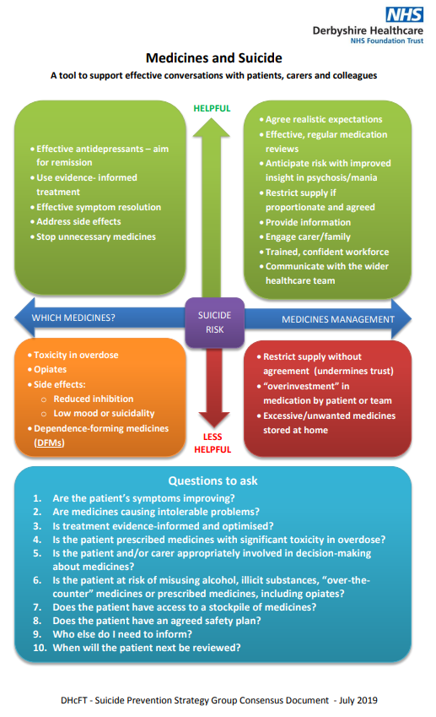

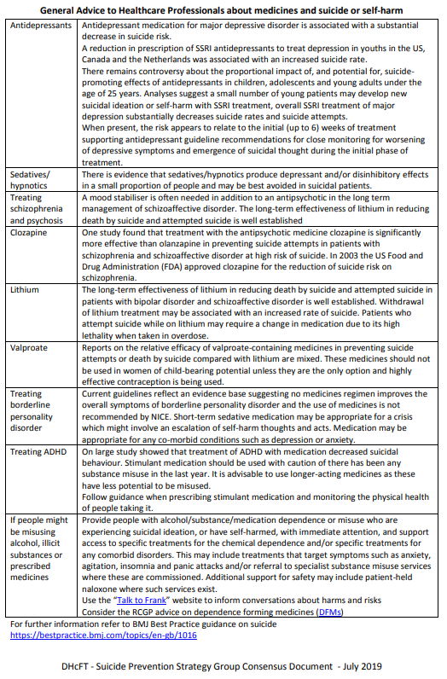

# Appendix 2: Shropshire and Telford & Wrekin Bereavement Service Flyer

